Adventurer Family
Blessing Service

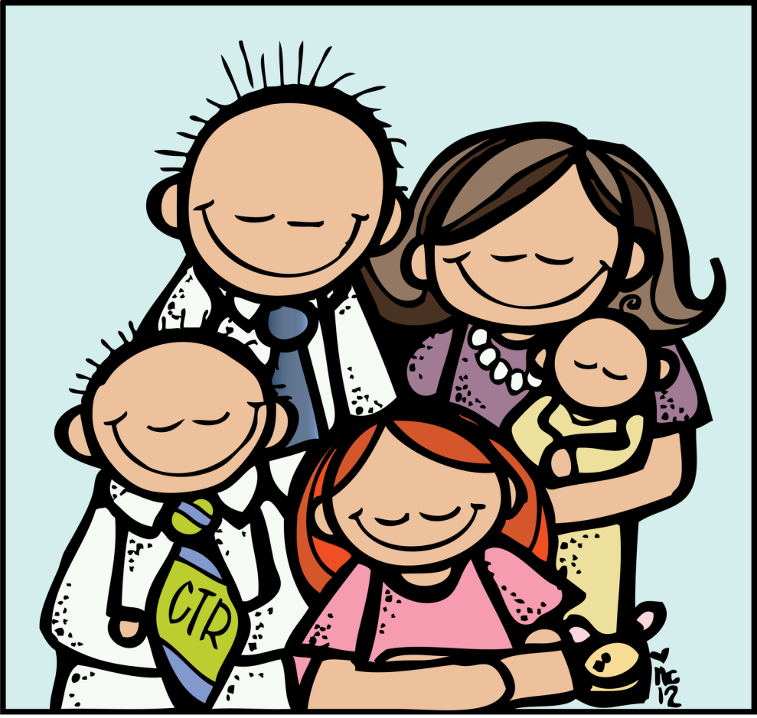

(Club’s name) Adventurer Club
November 00, 0000

PARENTS PROGRAM
- FAMILIES ENTER

- PRESENTATION OF FAMILIES

- THE TRADITION OF BLESSING

- READING FROM SCRIPTURES
Parents: And these words which I command you today shall be in your heart. You shall teach them diligently to your children, and shall talk of them when you sit in your house, when you walk by the way, when you lie down, and when you rise up. – Deuteronomy 6:6-7
Adventurers: Children, obey your parents in the Lord, for this is right. “Honor your father and mother,” which is the first commandment with promise: “that it may be well with you and you may live long on the earth.” Ephesians 6:1- 3

- AFFIRMATION OF VALUE
Parent’s letter to their children

- FAMILY PLEDGE
Adventurers, you are growing to be such fine young boys and girls! Now that you are old enough to understand, your parents want you to know about the blessings they want to give you with God’s help. Every person needs to know that they are loved. When God gave you to your parents, He gave them a very special person to love for the rest of their lives.
Parents: (Child’s name), I pledge to you the blessing of my love, always, no matter what.
In order to grow, every person needs food and shelter. Every person needs to be taught how to live in a happy loving way.
Parents: (Child’s name), I pledge to you the blessing of my help, in every way I can give it, so you can grow strong in Jesus.
Every child makes mistakes and needs to know that they are forgiven. Every parent makes mistakes too.
Parents: (Child’s name), I pledge to you the blessing of forgiveness when you make mistakes and apologies when I make mistakes.
Adventurers, you are a very important part of your family. You have the power to help make your family a happy place or a sad place. Do you pledge to do your part to make your family a happy family?
Parents: We do.

- SONG OF BLESSING – He is our Song #119
FAMILY
Family, we are family,
Jesus, He I our God
And I’m so glad He’s brought us all together
I’m so glad that the Father is our God.
We share good times together,
We share the bad times, too.
And we all know our family always loves us
That’s because we were all first loved by You!
- DEDICATORY PRAYER

